Instruction of optimal_accuracy_metrics (Python Code）
Yan Wang (daiki.wang@connect.polyu.hk), Xiaolin Zhu (xiaolin.zhu@polyu.edu.hk)
Department of Land Surveying and Geo-Informatics
The Hong Kong Polytechnic University
Version: 24 March 2022
Reference
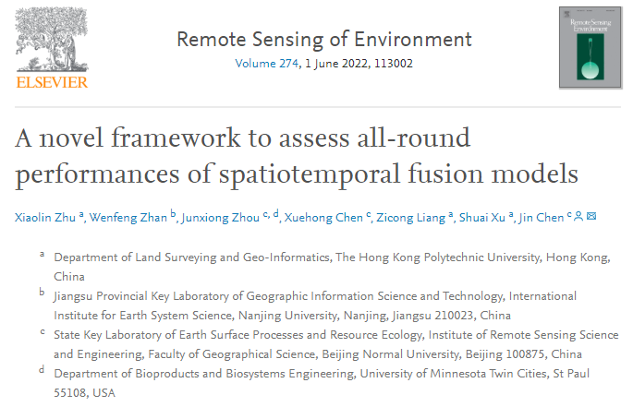
Download link:
https://doi.org/10.1016/j.rse.2022.113002
Input data preparation
1) Two satellite images are required. One is the reference image and another is the fused image. These images can be multi-spectral reflectance images, single band image, or index image (such as NDVI). The test data is 3 bands (green, red, NIR) images.
Operation Steps
Step1: Configure Anaconda
Anaconda is selected as a virtual environment
- Download Anaconda from https://www.anaconda.com/distribution/ for your operating system and install (Please check the box of “Add Anaconda to the system PATH environment variable”)
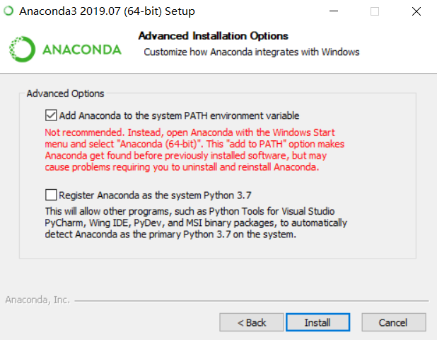
Spyder
- After the anaconda is installed, you can find the spyder icon () under anaconda folder. Spyder is a powerful scientific environment written in Python, for Python, and designed by and for scientists, engineers and data analysts. It features a unique combination of the advanced editing, analysis, debugging and profiling functionality of a comprehensive development tool with the data exploration, interactive execution, deep inspection and beautiful visualization capabilities of a scientific package.
- Spyder offers built-in integration with many popular scientific packages, including NumPy, SciPy, Pandas, IPython, QtConsole, Matplotlib, SymPy, and more

Install the required packages
- Open Anaconda Prompt in the window starter
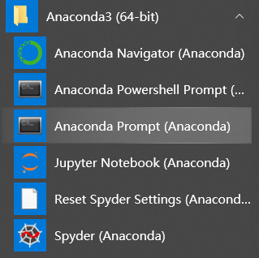
- Type “conda install gdal” and press “enter” to install the required Python package gdal (other required packages include os, numpy, pandas, scipy, tkinter, datetime, many of which have been included in Anaconda, if not, please use conda install packagename to install required packages). Type “y” and press “enter” when the window shows the following message:
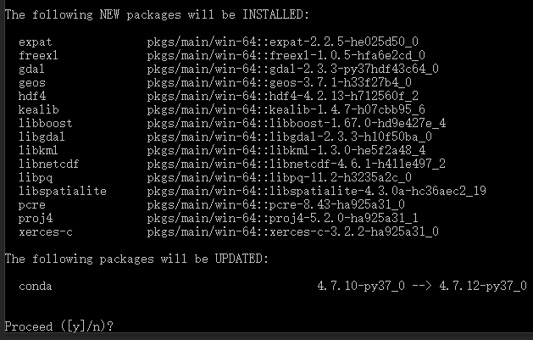

- It is done when you see the following text (if no errors appear, then the package was successfully installed)
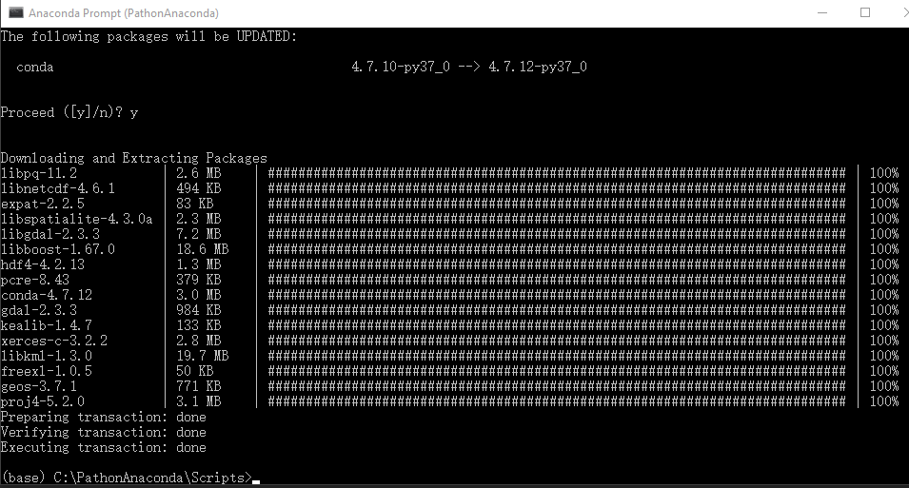
Step 2 Data Preprocessing
- There is no preprocessing procedure before running this code. You need to ensure the two input images have the same dimensions (i.e. same raster width, raster height, and raster bands) and same DN range.
Note: the provided test data can be directly fed to the program.
Step 3 set the parameters
- Please follow the explanation to set the parameters. The default parameters are used for test data, you can change these parameters according to your own data before running this program.
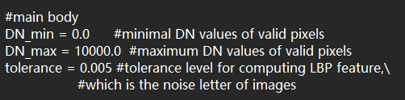

Step 4 Run
Click Run icon
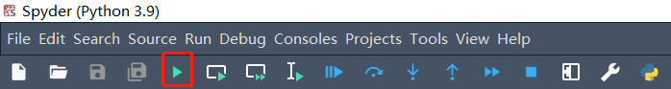
Open files according to the name of pop-up windows
- open the reference fine-resolution image
- open the fused fine-resolution image

NOTE: the result will be saved to the same folder as the reference image you opened. All accuracy metrics ranges -1 to 1 (RMSE 0-1) regardless of what DN ranges are for the input images, because they are normalized to 0-1 before computing metrics in the code.
The output would be slightly different from that of IDL code. It is because IDL uses the specific way for dealing with floating-point numbers. A detail description can refer to Accuracy and Floating Point Operations (l3harrisgeospatial.com). These slight difference between IDL and Python codes will not affect comparison among fused images.

Thanks for using optimal_accuracy_metrics algorithm. If you meet any problems, please feel free to contact Mr. Yan Wang or Dr. Xiaolin Zhu.

